Name: Muhammad Ali
Lab Course Title: Engineering Drawing & CAD Lab
Lab Course Code: ME-104L
Semester: 2rd Semester (Spring 2020)
REG #. 19PWCSE1801

Lab Report
Engineering Drawing & CAD Lab
Department of Computer system Engineering



Submitted to:
Engr. Asim Ahmad Riaz

Lab Report # 02

Introduction to AutoCAD Graphical User Interface (GUI) and General commands, setting up drawing sheet, Units & toolbars

Graphical user interface:-

When you start AutoCAD After installing you will be presented with Welcome Screen(Work, Learn and Extend) . Press close on it. Now AutoCAD window will be open. For better understanding of AutoCAD User Interface.

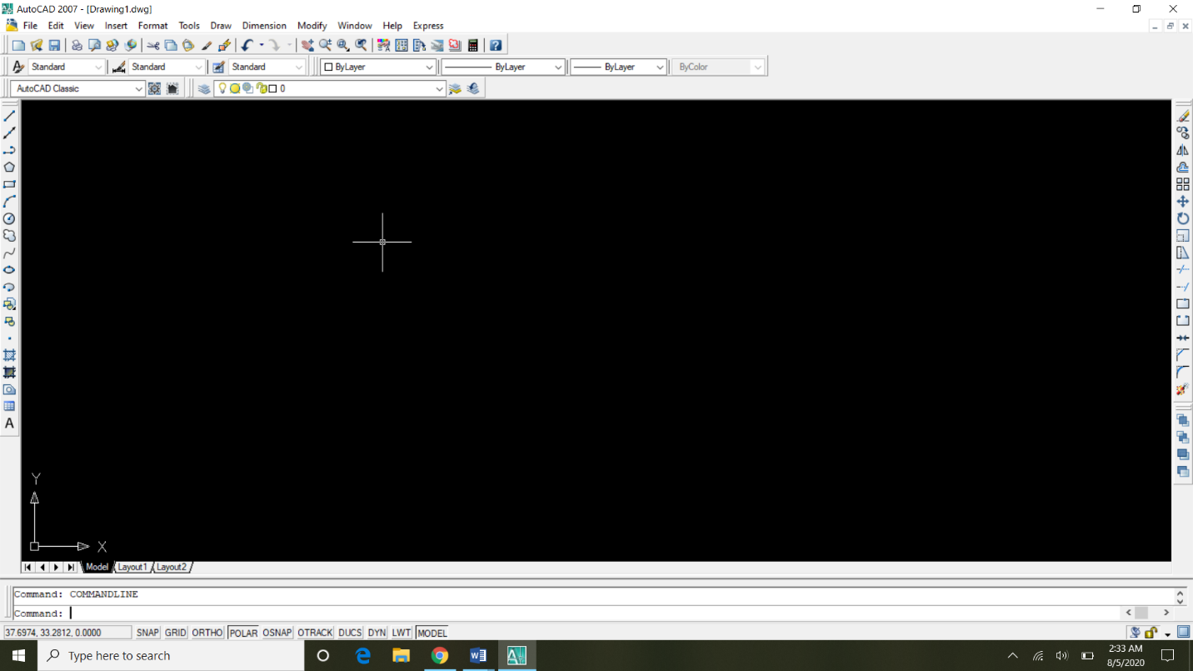

General commands:-

Title bar:-

The title bar is a horizontal bar located at the top of a window in a GUI. It displays the title of the software, name of the current document, or other text identifying the contents of that window. For example, in the picture below, the title bar displays the program name "TextPad" and the document name "Document1" that is currently being edited.

Menu bar:-

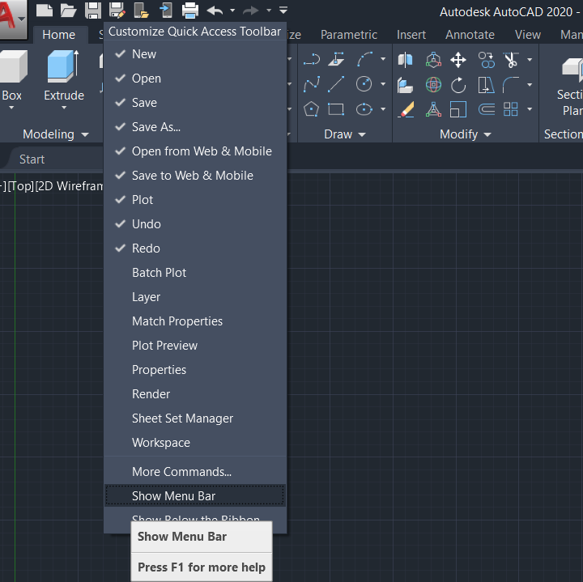

In Toolbars, we learn about the different types of designing tools such as line command, circle command, dimensions command, text command and many more. Let us start our tutorial with great enthusiasm and make AutoCAD an easy task for us.

